Homework # 6

Ruchi Panwar (rpanwar@kent.edu)

Advance Database

Fall 2015

Professor: Dr. Gregory S DeLozier

Oct 27, 2015

**Todo App using ORM(Peewee)**

1. models.py & app.py

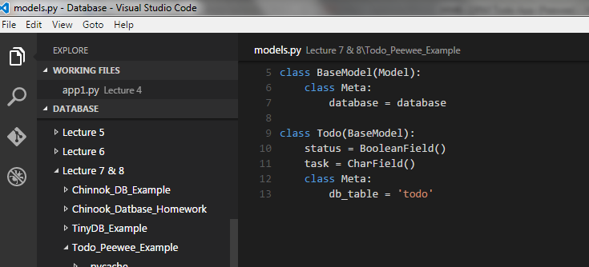

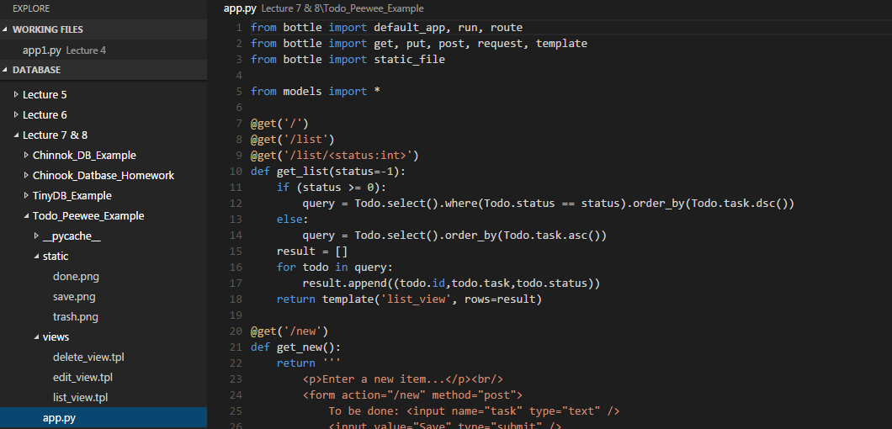

1. Code can be found on the below Github links (Lecture 7 & 8)

<https://github.com/rpanwar01/Database/tree/master/Lecture%207%20%26%208%20%26%20Chinook%20Database%20homework/Todo_Peewee_Example>

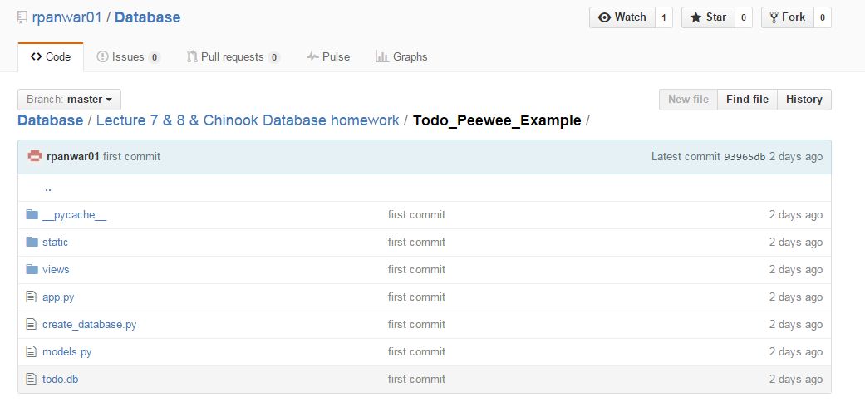

1. Execution and output of Todo app:

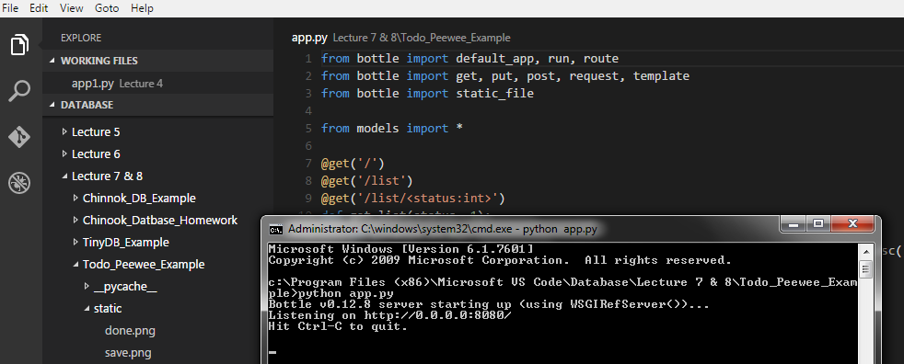

1. Home page of Todo app:

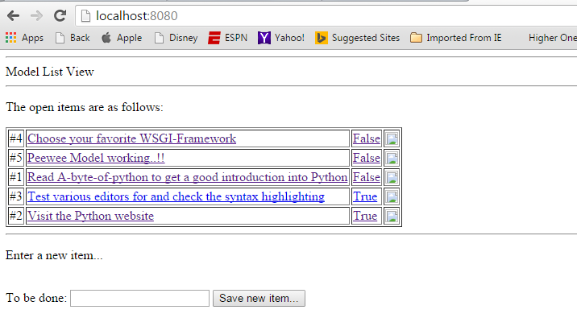

1. Edit an Item:

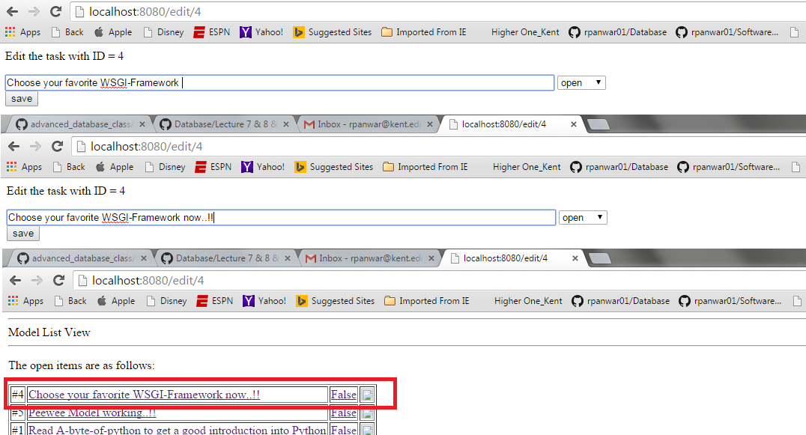

1. Add new Item:

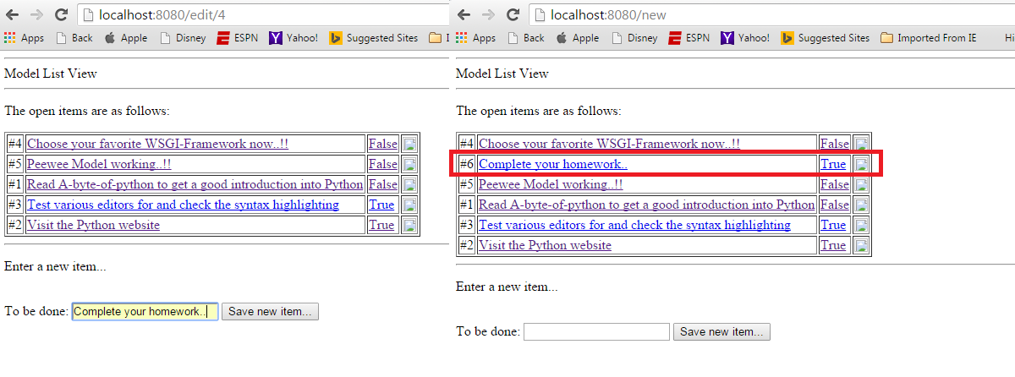

1. Delete an Item:

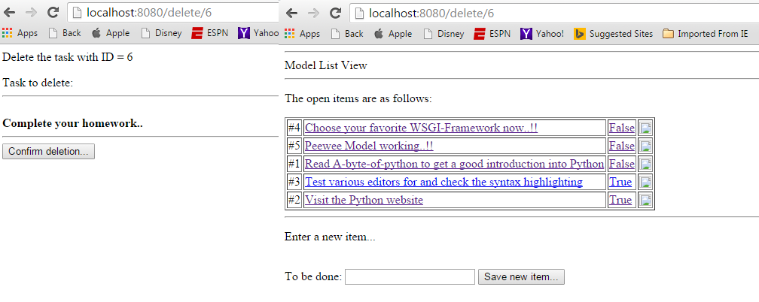

**Peewee Tutorial**

Tutorial page : <http://docs.peewee-orm.com/en/latest/peewee/quickstart.html>

#1 Model Definition

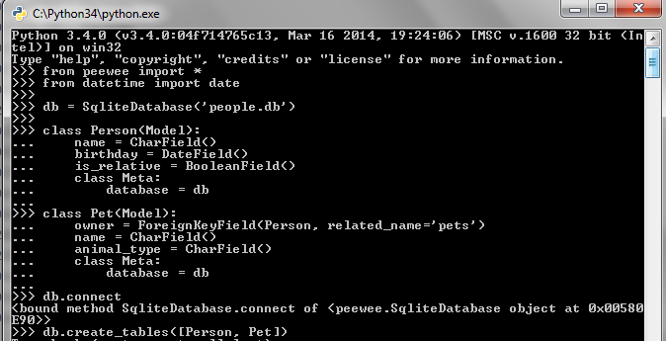

#2 Storing Data

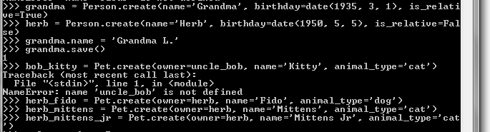

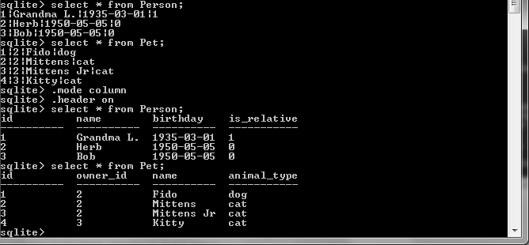



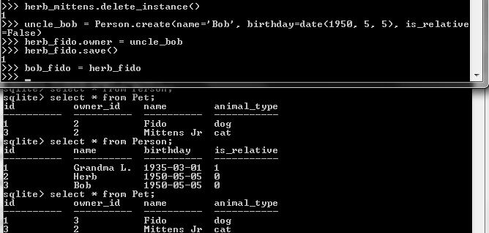

#3 Retrieving Data

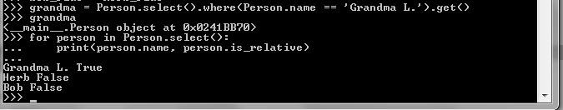

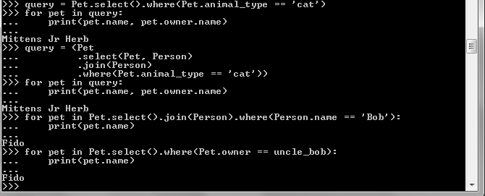

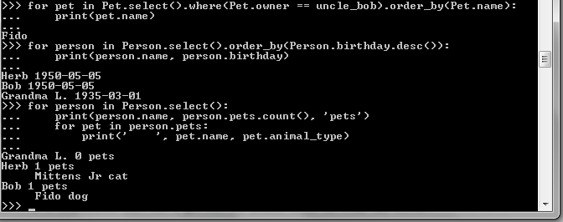

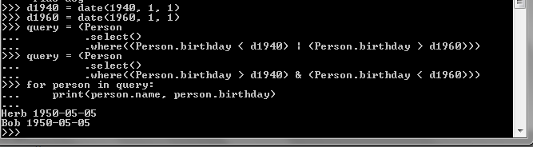

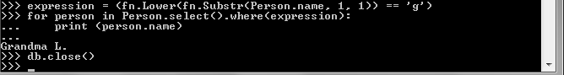

**SQLAlchemy Tutorial**

Tried SQLAlchemy at home.

